Documents embedded: 374
Embedding model: all-MiniLM-L6-v2
Collection: jazzercise_schedule

TEST: Waikiki January 19 cancellation
QUESTION:
Is there a Waikiki Community Center
class on January 19, 2026?
RETRIEVAL STRATEGY:
Pure semantic vector similarity
...
RETRIEVAL RESULT:
FAIL - Expected evidence 'NO CLASS'
NOT found in Top 4.

============================================================
BASELINE RETRIEVAL SUMMARY
============================================================
Tests passed: 2/3
Accuracy: 66.7%

REVIEW - Pure semantic retrieval failed at least one test.
Test Failed-
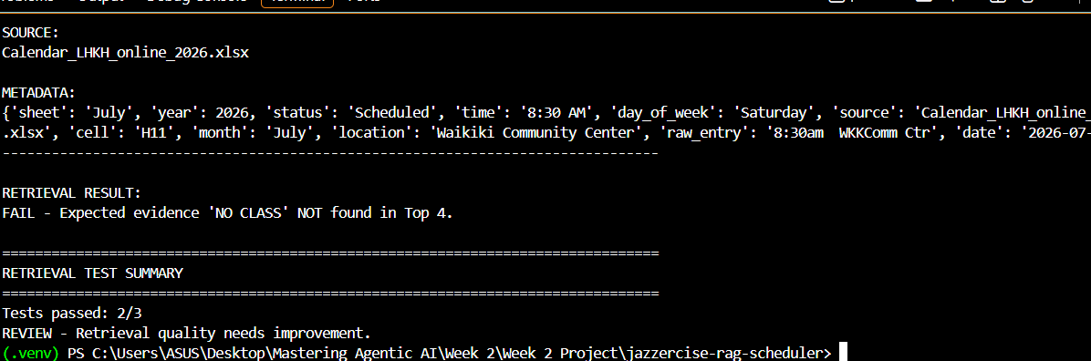

After Improvement retrieval test ; Top rank=1
